**How to vote Greens in the Perth By-Election**

This election the Greens want to create a future for all of us by electing our candidate Caroline Perks for Perth.

This Perth by-election you have 15 options on the ballot paper.

**If you are voting by phone**

If you are voting by phone these options will be read out to you in the following order. We have put numbers next to how we would recommend you vote if you want to support The Greens (WA)

MATHESON, Julie (7)

ARIELLI, Nicole Animal Justice Party (2)

GRAYDEN, Jim Independent (11)

DU PREEZ, Wesley Liberal Democrats (10)

SCOTT, Colin Sustainable Australia (8)

MULLINGS, Ben The Australian Mental Health Party (3)

GORMAN, Patrick Australian Labor Party (4)

HARFOUCHE, Gabriel Australian People's Party (9)

COLLINS, Paul Independent (6)

PERKS, Caroline The Greens (WA) (1)

HAMMOND, A Science Party (5)

JOUBERT, Ellen Australian Christians (13)

ROBINSON, Tony ALA (15)

BRITZA, Ian Independent (12)

MASON, Barry Citizens Electoral Council (14)

If you want to be able to read those options in order we recommend voting

1. Caroline Perks, The Greens (WA)
2. Nicole Arielli, Animal Justice Party
3. Ben Mullings, The Australian Mental Health Party
4. Patrick Gorman, Australian Labor Party
5. A Hammond, Science Party
6. Paul Collins, Independent
7. Julie Matheson
8. Colin Scott, Sustainable Australia
9. Gabriel Harfouche, Australian People’s Party
10. Wesley Du Preez, Liberal Democrats
11. Jim Grayden, Independent
12. Ian Britza, Independent
13. Ellen Joubert, Australian Christians
14. Barry Mason, Citizens Electoral Council
15. Tony Robinson, ALA

You have until 12pm on Saturday the 28th of July to register as someone who will phone vote. You have until 6pm on Saturday the 28th of July to complete your phone vote.

Authorised by S. Greer, The Greens (WA), 1/440 William St, Perth 6000.

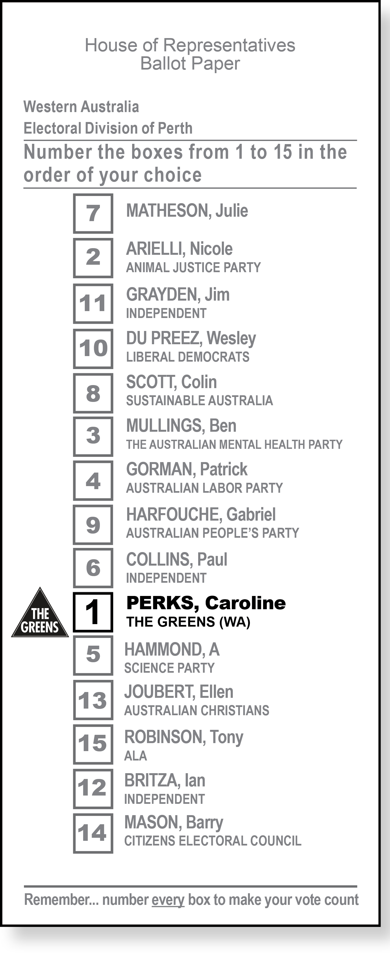**If you are voting at a polling booth:**

The Greens (WA) suggest that on the ballot paper you put a ‘1’ in the box next to Caroline Perks, The Greens (WA) who is the 10th option on the ballot paper.

You should number the other box’s in an order of your choice.

Our suggestion:

Number 1 in the box: PERKS, Caroline The Greens (WA)

Number 2 in the box: ARIELLI, Nicole Animal Justice Party

Number 3 in the box: MULLINGS, Ben The Australian Mental Health Party

Number 4 in the box: GORMAN, Patrick Australian Labor Party

Number 5 in the box: HAMMOND, A Science Party

Number 6 in the box: COLLINS, Paul Independent

Number 7 in the box: MATHESON, Julie

Number 8 in the box: SCOTT, Colin Sustainable Australia

Number 9 in the box: HARFOUCHE, Gabriel Australian People's Party

Number 10 in the box: DU PREEZ, Wesley

Number 11 in the box: GRAYDEN, Jim Independent

Number 12 in the box: BRITZA, Ian Independent

Number 13 in the box: JOUBERT, Ellen Australian Christians

Number 14 in the box: MASON, Barry Citizens Electoral Council

Number 15 in the box: ROBINSON, Tony ALA

On election day you are allowed to nominate someone to assist you with voting.

Senator Jordon Steele-John has said about Caroline Perks “Perth have a clear choice; Caroline has dedicated her career to action on climate change and ensuring a future for all of us”.

The Greens will prioritise a future for all of us. Vote Greens to:

END CORPORATE INFLUENCE

* Ban political donations from corporations so that big businesses can no longer buy influence with Labor and Liberal politicians.
* Stop the revolving door of politicians becoming lobbyists.

ENSURE A FUTURE FOR PEOPLE AND THE ENVIRONMENT

* Support renewable energy technology to help tackle climate change and power a smarter, more sustainable economy.
* Increase the minimum wage, ensuring everyone receives a good wage and conditions.
* End offshore detention of refugees.
* Ban live animal exports.

FUND BETTER PUBLIC SERVICES

* Make big corporates pay their fair share of tax.
* Invest money in hospitals and schools, so everyone can access the services they need to live a good life.
* End homelessness by ensuring everyone has a safe place to live.

READ MORE ABOUT OUR POLICIES ONLINE: GREENS.ORG.AU

We acknowledge the Whadjuk Nyoongar people as the original custodians of this land. We pay our respects to their elders past, present and future

Authorised by S. Greer, The Greens (WA), 1/440 William St, Perth 6000.